HD 120066

HD 120066 is a 1.07 M☉, G0 star1. Based on 81 RV HIRES measurements obtained between 1997 and 2020 and 107 RV Apf obtained between 2013 and 2020, the CL survey reported a LPGP with a period of days, a minimum mass of MJup and eccentricity of .

In the present study, 175 RV Tull measurements obtained between 1999 and 2019 were added to the CL survey’s dataset. DPASS and MCMC (1000 walkers and 400000 iterations) were used to fit the data. A LPGP with a period of 32435 days, a minimum mass of 3.3 MJup and an eccentricity of 0.86 were found with DPASS, with a corresponding rms of residuals of 6.3 m/s, and a LPGP with a period between 18400 and 78300 days, a minimum mass of 3.3 ± 0.1 MJup and an eccentricity of were found using MCMC. Yet, as the RV curve of HD 120066b covers only a maximum, the period (or *a*) is not well constrained.

To explore the range of possible values, the semi-major axis was fixed to different values and the data fitted with DPASS. *a* up to 70 au do not significantly change the rms of the residuals (6.7 m/s against 6.3 m/s with *a* left free). In this case (referred to as constrained *a*), the minimum mass is 3.9 MJup and the extremely high eccentricity is 0.95. However, changing the stellar offset does not change the possible solutions beyond those found with the constrained semi-major axis.

The fits are shown in Fig 1, and the corner plot in Fig 2, and the results summarized in Table 1.

Conclusion: The properties found in the CL survey for HD 120066b are not confirmed. Additional data are needed to further constrain its orbital properties.

Figure 1: Left: fit of the HD 120066 RV with DPASS. Red - Hir94, green - Hir04, blue - Apf, cyan - Tull. The blue curve shows the best fit. Middle: fit of the HD 120066 RV with DPASS, with the minimum *a* fixed at 70 au. The points are the same as on the left. The blue curve shows the best fit. Right: fit of the HD 120066 RV using MCMC. The black curve shows the best fit. The colorbar corresponds to the log-likelihood of the fits.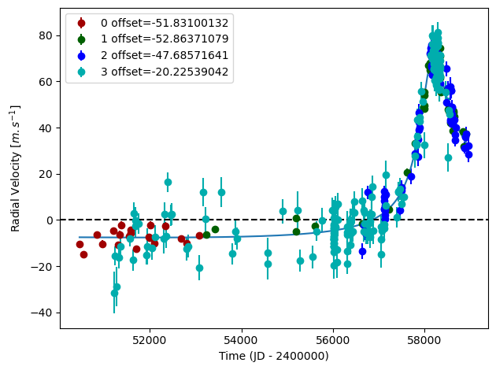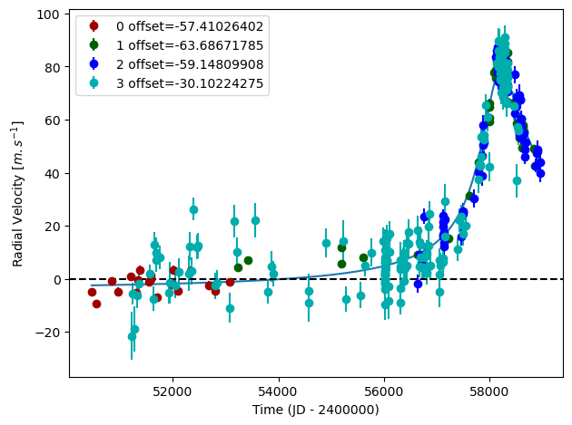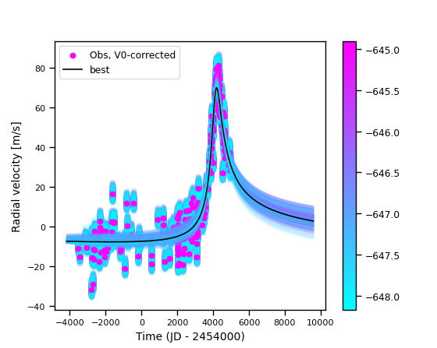

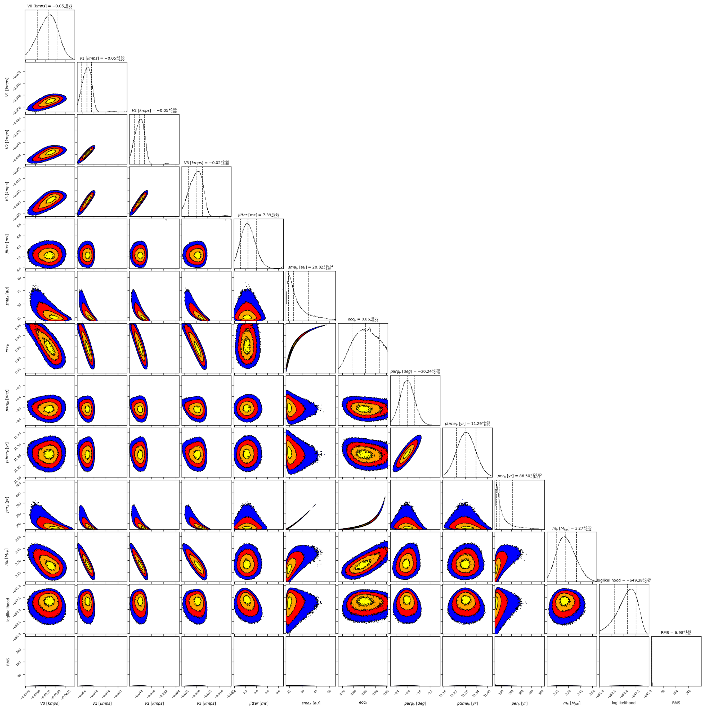

Figure 2: Corner plot of posteriors for the one-planet model MCMC fit of HD 120066 RV data.

| Parameter | Priors | | | Posteriors | | | CL survey |
| --- | --- | --- | --- | --- | --- | --- | --- |
|  | DPASS | | MCMC | DPASS | | MCMC |  |
|  | Free priors | Constrained *a* | Free priors | Free priors | Constrained *a* | Free priors |  |
| *a* (au) | [0,100] | up to 70 | [1,100] | 20.4 | 70 | 14 – 37 |  |
| Msin(i) (MJup) | [0,100] | [0,100] | [0.5,10] | 3.3 | 3.9 | 3.3 ± 0.1 |  |
| Eccentricity | [0,0.95] | [0,0.95] | [0,0.99] | 0.86 | 0.95 |  |  |
| Instrumentals offsets (km/s) | [-60,60] | [-60,60] | [-1,1] | Hir94: -0.052  Hir04: -0.053  Apf: -0.048  Tull: -0.020 | Hir94: -0.057  Hir04: -0.064  Apf: -0.059  Tull: -0.030 | Hir94: -0.052 ± 0.003  Hir04: -0.053 ± 0.003  Apf: -0.048 ± 0.003  Tull:-0.020 ± 0.003 |  |
| Stellar jitter (m/s) | [0,40] | [0,40] | [0,10] | 7.1 | 7.9 |  |  |
| Argument of periastron (°) | [0,360] | [0,360] | [0,360] | 339 | 343 | 340± 3 |  |
| Phase | [0,1] | [0,1] | [0,1] | 0.79 | 0.28 | 0.05 – 0.22 |  |

Table 1: HD 120066. Summary of priors and posteriors obtained with DPASS and MCMC, compared to the properties reported by the CL Survey.

References

1. Blunt, S. et al. Radial Velocity Discovery of an Eccentric Jovian World Orbiting at 18 au. *Astron. J.* 158, 181 (2019).